Chapter 4
Knowledge Exercise Answers

- Linked lists do not require contiguous memory, array based structures do. Also, array based structures (unless they are full) do not use all the memory assigned to them; linked structures do.

- Access into an array based structure is faster than access into linked list.

- A fragmented memory is a memory media in which the available storage is not one contiguous block of storage.

- In dynamic data structures, the maximum number of nodes that can be stored in the structure is dynamic. That is, the maximum capacity of the structure can be expanded at run time.

- The entire system memory is in use.

- One thing in common to all linked lists is that each node in the list contains at least one field that stores the address of another node in the structure.

- The last node in a singly link list, by definition, stores a null value instead of the address of another node in the structure.

- The list header of a singly linked list stores the address of the first node in the list. In some implementations, this could be a dummy node.

- The advantage of implementing a stack using a singly linked list is that it is a very efficient use of system memory. The total system memory allocated to the structure will grow and shrink as nodes are pushed and popped (respectively), and also the likelihood of an overflow error is greatly reduced.

- a)

Node X’s information
500
30
Node A’s information
30
200
Node C’s information
null
60
Node P’s information
50
500
RAM

b), c), and d)
Node X’s information
null
30
Node A’s information
60
200
Node C’s information
500
60
Node P’s information
30
500
RAM
h
200
e)
Node A
Node C
Node P
Node X
null
h
f)

200
Node A
60
200
Node C
500
60
Node P
30
500
Node X
null
30
h
g) The contents of the field back that ordered the nodes in reverse alphabetic order would be: Node A’s back field would contain null; Node C’s back field would contain 200; Node P’s back field would contain 60; and Node X’s back field would contain 500;

11)
431
200
699
75
60
21
699
500
128
21
30
null
128
null
75
431
X’s key
info
30
P’s key
info
500
C’s key
info
60
A’s key
info
200
l
next
l
l
l
next
next
next
next
l
h
linked Node objects
deep copies of client objects

12) The first line of the algorithm creates a new linked Node, n, and second line copies the null value from the dummy node’s next field into the next field of the Node n. The third line of the algorithm places the location of the Node n into the next field of the dummy node, and finally the location of the deep copy of the client’s node is placed into the l field of node n. Then when we traverse the list, the header takes us to the dummy node, which takes us to the new Linked Node whose l field locates the client’s information and whose next field contains a null reference that correctly indicates the end of the list.

13) p = h;
while (p.next != null) // locate the last node in the list
{ p = p.next; }
Node n = new Node(); // create a new linked list Node object
p.next = n; // add the linked Node object to the end of the linked list
n.next = null;
n.l = newListing.deepCopy(); // deep copy the information, reference the copy

14)To find the dominate term in the speed equation for algorithm that is the answer to exercise 11 (inserting a node at the end of a singly linked list) we will assume there are N nodes in the list. The while loop will execute N times, ending when it is pointing to the last node in the list. Each time through the loop, one memory access is performed to fetch the location of the next node (assuming p is stored in a register). Therefore, the dominate term in the speed equation is N and the algorithm id O(N).

15) a)

T
X
A
. .
h (the header)
D
C
p
q
. .

b)

T
X
A
. .
header
D
C
p
q
. .
X

c)
p = p.next;
p = p.next;
q.next = p;

16) a)

T
X
G
B
null
L
A
D
null
. . .
h1
h2
p
null
B
. .

16) b

T
X
G
B
null
L
A
D
null
. . .
h1
h2
p
X
X
q
q
q

16) c
q = h2; // find the last node in list L2
while(q.next != null);
q = q.next;
q.next = p.next; // insert L2 into L1
p.next = h2;
h2 = null;

17)
q1 = h1;
p1 = q1.next;
q2 = h2;
p2 = q2.next;
while (q1 != null)
{ q1.next = q2;
q2.next = p1;
q1 = p1;
p1 = p1.next;
q2 = p2;
p2 = p2.next;
}

18) Assuming the method getKey returns the key from a client listing, and the method compareTo returns a positive number if the key of the object that invoked it is greater than the key passed to it as an argument…
The pseudocode of the Insert algorithm to insert the client listing, newNode, is:
Node q = h;
Node p = q.next;
while ( p != null && newNode.compareTo(p.l.getKey()) > 0) // traverse
{ q = p;
p = p.next;
}
Node n = new Node(); // allocate a new linked node
n.next = q.next; // add the new linked node to the singly linked list
q.next = n;
n.l = newNode.deepCopy(); // place a deep copy of the client node in the structure

The pseudocode of the Fetch algorithm to fetch the client listing whose key is targetKey is:
Node p = h.next; // set p to refer to the first node in the list
while ( p != null && p.l.getKey().compareTo(targetKey) < 0 )
{ p = p.next; }
if (p != null && p.l.getKey().compareTo(targetKey) == 0) // node found
return p.l.deepCopy( );
else
return null; // the request node is not in the list

The pseudocode of the Delete algorithm is:
Node q = h;
Node p = q.next;
while ( p != null && p.l.getKey().compareTo(targetKey) < 0 )
{ q = p;
p = p.next;
}
if (p != null && p.l.getKey().compareTo(targetKey) == 0) // node found
{ q.next = p.next; // delete the node
return true;
}
else
return false;
The pseudocode of the Update algorithm is the same as the unsorted singly linked list Update algorithm

19) The Insert operation speed function is: 1 + 1 + n/2(2 + 1) + 5 = 7 + 3n/2, which is O(n). (Assuming, on the average we insert half way down the list so that the traversal loop will execute n/2 times.)

The Fetch operation speed function is: 2 + n/2(2 + 1) = 2 + 3n/2, which is O(n). (Assuming, on the average we fetch half way down the list so that the traversal loop will execute n/2 times.)

The Delete operation speed function is: 1 + 1 + n/2(2 + 1) + 3 = 5 + 3n/2, which is O(n). (Assuming, on the average we delete half way down the list so that the traversal loop will execute n/2 times.)

The Update operation speed function is the sum of the speed functions of the Delete and Insert operations: 5 + 3n/2 + 7 + 3n/2 = 13 + 3n, which is O(n). (Assuming, on the average we delete and insert half way down the list so that the traversal loops will execute n/2 times.)

The average operation speed function is: [7 + 3n/2 + 2 + 3n/2 + 5 + 3n/2 + 13 + 3n] / 4 = [27 + 15n/2] / 4 = 6.75 + 1.875n, which is O(n).

20) Assuming all operations are equally probable, the ratio of the average speed of an Unsorted-Optimized array structure to the average speed of a Singly Linked List structure containing 1,000,000 information nodes is ≤ (0.75n + 1.5) / (1.13n + 3). For n = 1,000,000 this is ≈ 0.75/1.13 = 0.664 .

21) The garbage collection is performed by the Java memory manager, which collects all objects that are no longer referenced by a program reference variable. The collection of a Node object and a client Listing object is initiated by Line 37 of Figure 4.15. Since after that line the deleted linked Node object is no longer referenced it is collected, and its collection results in no program variable referencing the Listing object, so it is collected too.

22) a) Density = 1 / (1 + 12 / (n * w) + 8 / w) = 1 / (1 + 12 / (50 * 8) + 8 / 8) =
1 / (1 + 0.03 + 1) = 0.493
b) Density = 1 / (1 + 12 / (n * w) + 8 / w) = 1 / (1 + 12 / (10⁶ * 200) + 8 / 200) =
1 / (1 + 0.000000005 + 0.04) = 0.962

23)
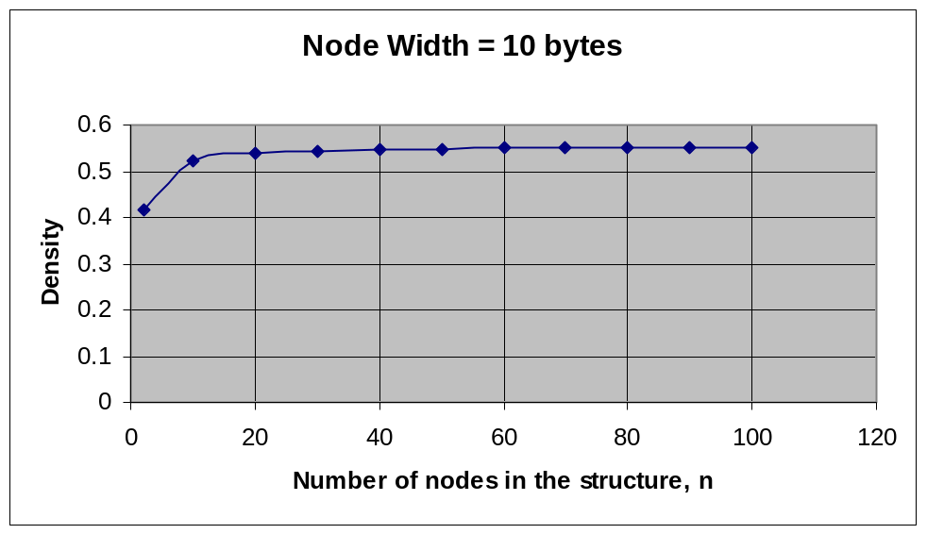

24) When we want to update (or fetch) the contents of a given field for all the nodes in a singly linked list, it would be more efficient to use an iterator to access the nodes.

